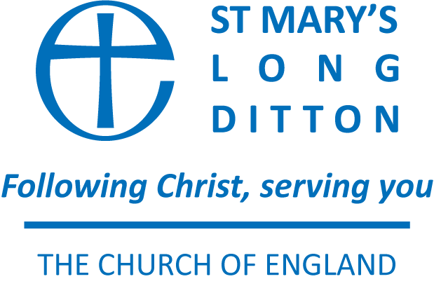

STANDING ORDER REQUEST FORM - COMPLETE IN BLOCK CAPITALS AND GIVE TO YOUR BANK

To my bank,

Please pay ‘Long Ditton Parochial Church Council Community Account’
Account no. 10610909
At Barclays Bank Plc, Surbiton (sort Code 20-46-73)

The sum of £_____________ (Pounds)

Starting on __________ / _________/2023* and monthly* thereafter until further notice.

YOUR DETAILS AND SIGNATURE

Name
Address
Postcode
Signature
Date

YOUR BANK’S DETAILS

Bank Name
Bank Address
(correspondence address)
Post Code

YOUR BANK ACCOUNT

Account No.
Account Name

In case of queries please contact the Stewardship Secretary, Sarah Carvalho, at
giving@stmaryslongditton.org.uk

